Ex.no:6 | DATA VISUALIZATION USING POWER BI
Date:

Aim:
To Load the data into PowerBI and transform the data and visualize it to get insights

Algorithm:
Algorithm 1: Importing Data into Power BI
Step 1
Open Power BI Desktop.
Step 2
Select:
Home → Get Data
Step 3
Choose Excel or CSV according to the dataset format.
Step 4
Browse and select the Retail_Sales dataset.
Step 5
Load the selected dataset into Power BI.
Step 6
Verify the imported dataset in Power BI.
Algorithm 2: Data Transformation using Power Query
Step 1
Select Transform Data to open Power Query Editor.
Step 2
Inspect the Retail_Sales dataset and identify data quality issues.
Step 3
Remove duplicate records from the dataset.
Step 4
Handle null or blank values in relevant columns.
Step 5
Standardize text values such as Region and Product.
Step 6
Verify the data types of numerical and categorical columns.
Step 7
Click Close & Apply to load the transformed data into Power BI.
Algorithm 3: Advanced Data Transformation
Step 1
Select the OrderDate column and examine its date format.
Step 2
Convert the OrderDate values into a consistent date format.
Step 3
Create a new ParsedDate column for standardized date values.
Step 4
Handle inconsistent or invalid date entries.
Step 5
Check the Quantity and Sales columns for invalid or negative values.
Step 6
Apply the required transformations and load the cleaned dataset into the data model.
Algorithm 4: Creating Calculated Column and DAX Measures
Step 1
Select the Retail_Sales table in Power BI.
Step 2
Create a calculated Revenue column using the appropriate DAX formula based on the dataset fields.
Step 3
Create DAX measures for important sales statistics.
Step 4
Calculate Total Sales using the SUM function.
Step 5
Calculate Average Sales, Maximum Sales, and Minimum Sales using appropriate DAX functions.
Step 6
Validate the calculated values and use them in dashboard visuals.
Algorithm 5: Dashboard Visualization and Reporting
Step 1
Create a Bar Chart to visualize sales across different products or product categories.
Step 2
Create a Pie/Donut Chart to represent the distribution of sales across categories.
Step 3
Create Card Visuals to display Total Sales, Average Sales, Maximum Sales, and Minimum Sales.
Step 4
Add a Region Slicer to enable interactive filtering of the dashboard.
Step 5
Add a suitable dashboard title and arrange all visuals neatly.
Step 6
Test the dashboard by selecting different regions and verify that the visuals update dynamically.
Step 7
Save the completed Power BI report as a .pbix file.

Output:

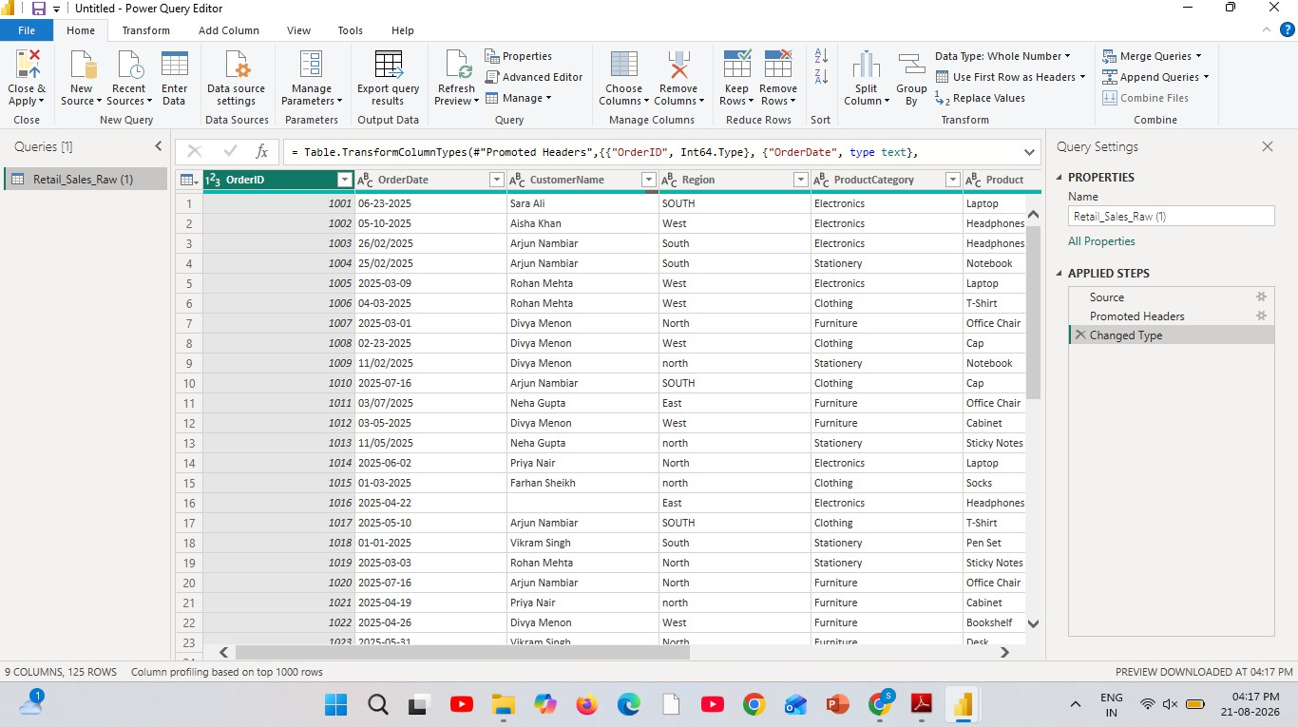

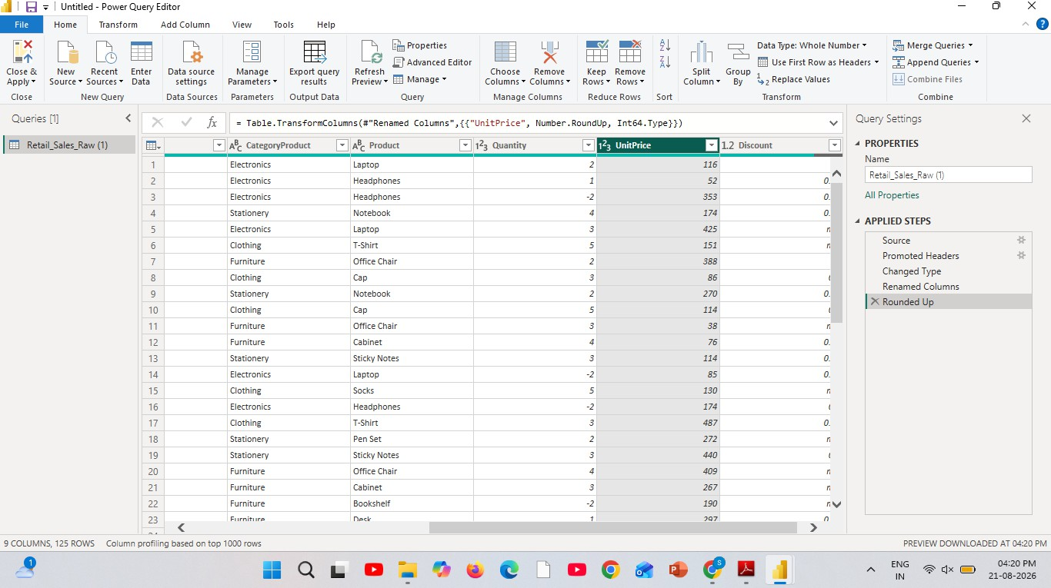
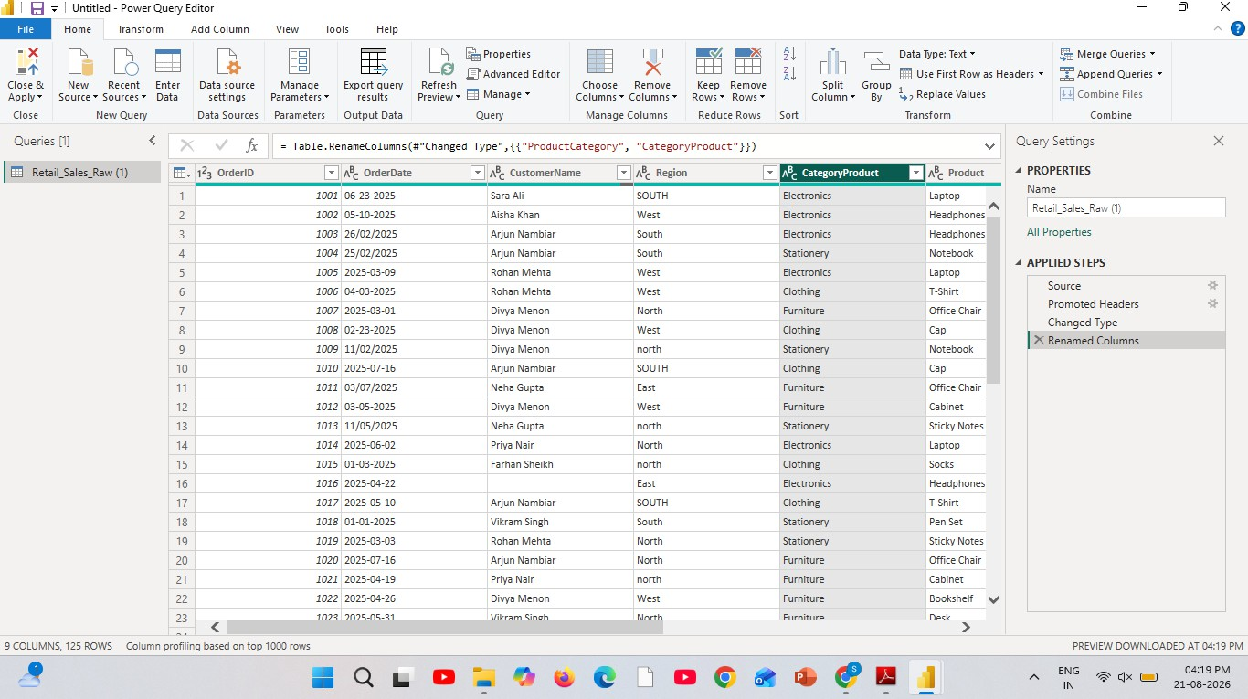



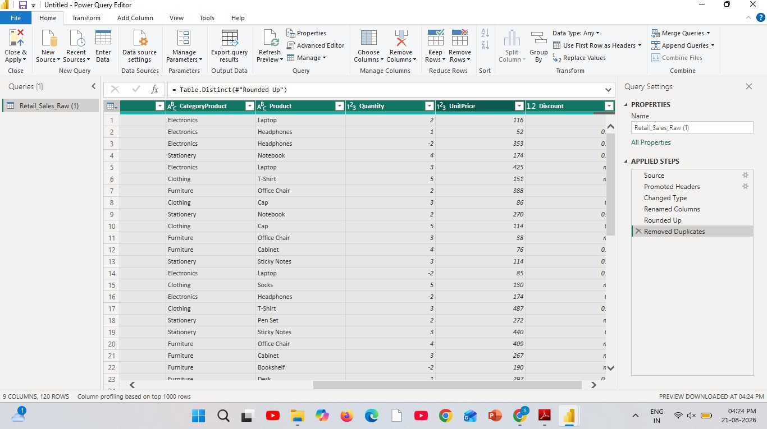

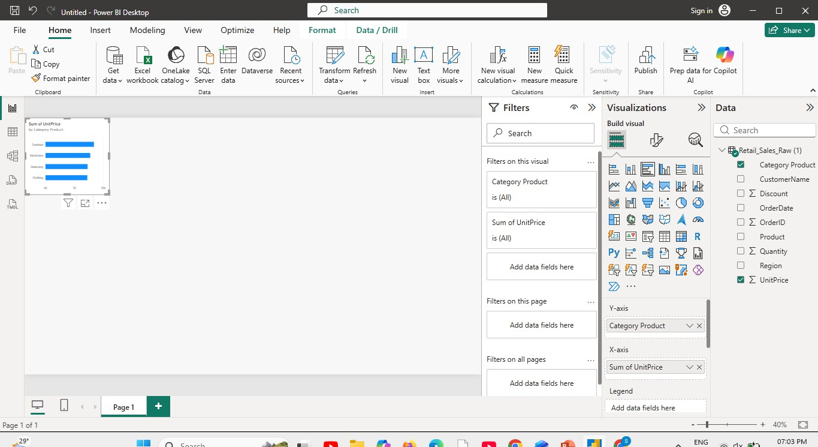

Result:

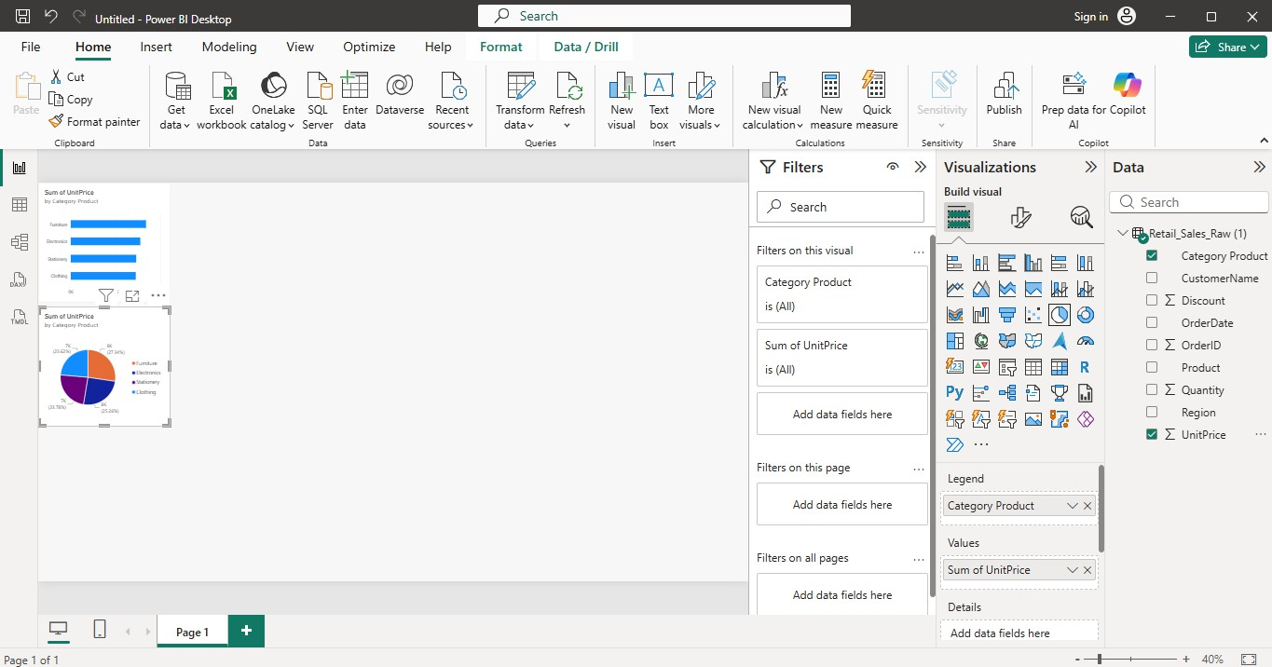

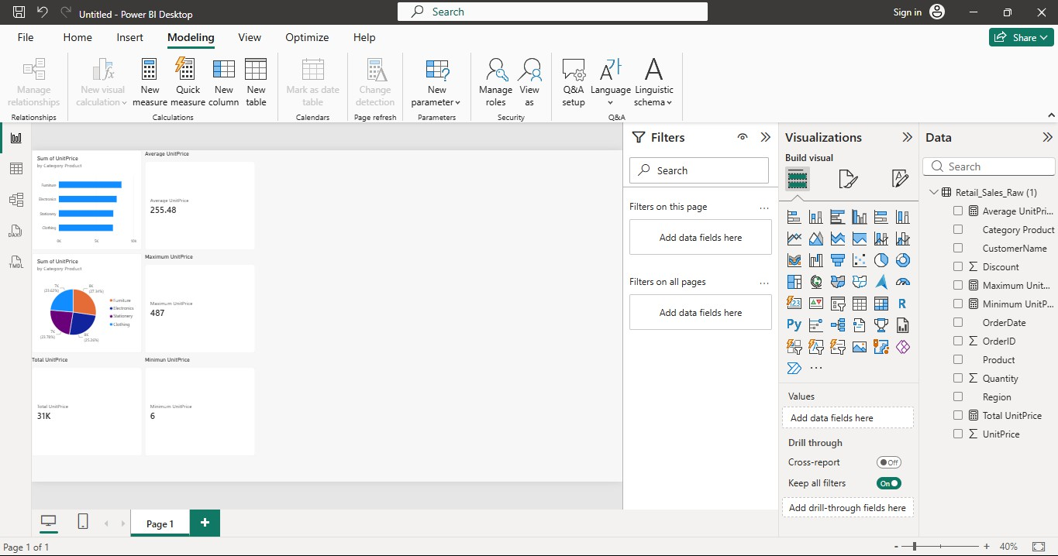

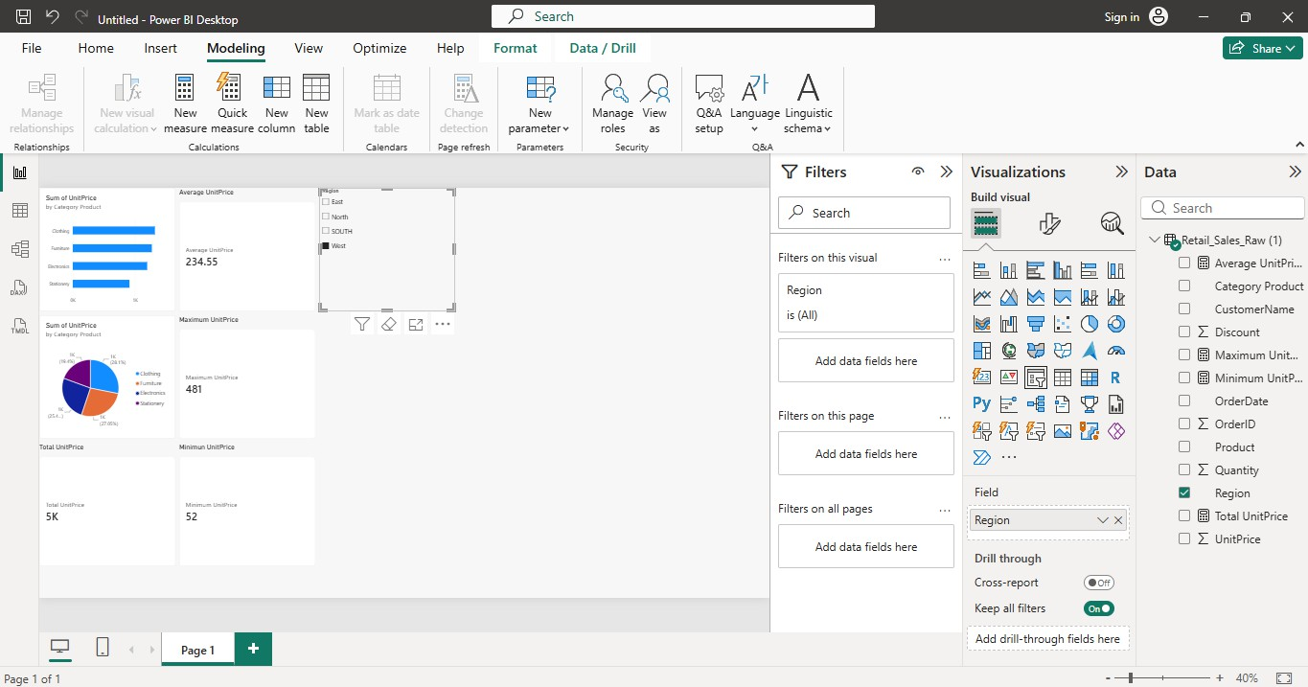

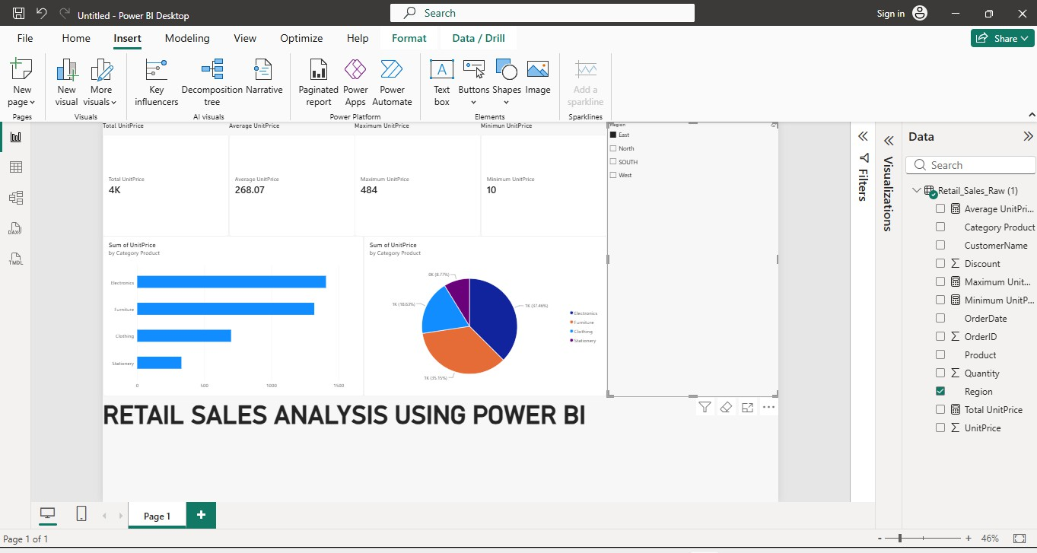

Result:

